Group 136: <https://edstem.org/us/courses/28987/discussion/2137058?comment=4941588>

* Do the implemented CRUD steps function as the team expects (e.g. if the team stated that a CRUD step worked but you found an error, please tell them)?
  + Yes. The CRUD implementation and errors described within are accurate and no errors found even when testing random functions on the Customers page. The Items page works as well when adding an item. But could be more restrictive on the item price up and down arrows working or clarifying that it is a float or a dollar amount.
* Would a user easily be able to use the UI to complete the step? If not or you have suggestions for how the UI can be improved, please elaborate.
  + The UI is basic and to the point. The user can easily navigate the interface. I do like how they have the edit and delete functions built into their tables. That helps restrict the user from any errors in what they are editing or deleting.
* What suggestions do you have for the team in any areas where they are blocked or having difficulty? Detailed helpful feedback will receive higher credit.
  + No major suggestions here. They already understand they are blocked with the search function. They could change the cancel button on both the customer and item pages to a “clear form” button or something along those lines, as it currently doesn’t do anything, just to give it some functionality, or just get rid of it altogether. Also, if the items to add are strictly coffees or drink styles, for a menu in the items page, it make help to clarify in the insert form to “Drink Name” or something…unless it is just tribal knowledge within the users of the page.

Group 75: <https://edstem.org/us/courses/28987/discussion/2136834?answer=4942266>

* Do the implemented CRUD steps function as the team expects (e.g. if the team stated that a CRUD step worked but you found an error, please tell them)?
  + Yes. All but the search function works, as described in the post. And no errors that I could find. I do like their intersection functions like adding a provider to a facility.
* Would a user easily be able to use the UI to complete the step? If not or you have suggestions for how the UI can be improved, please elaborate.
  + All pages in the project have ease of use. One thing I would add is to maybe highlight the page within each table page I am using. Just to help delineate between where I am and what I am doing. I also know this would take additional time and this is not a deal-breaker because without it the project is still easy on the user.
  + 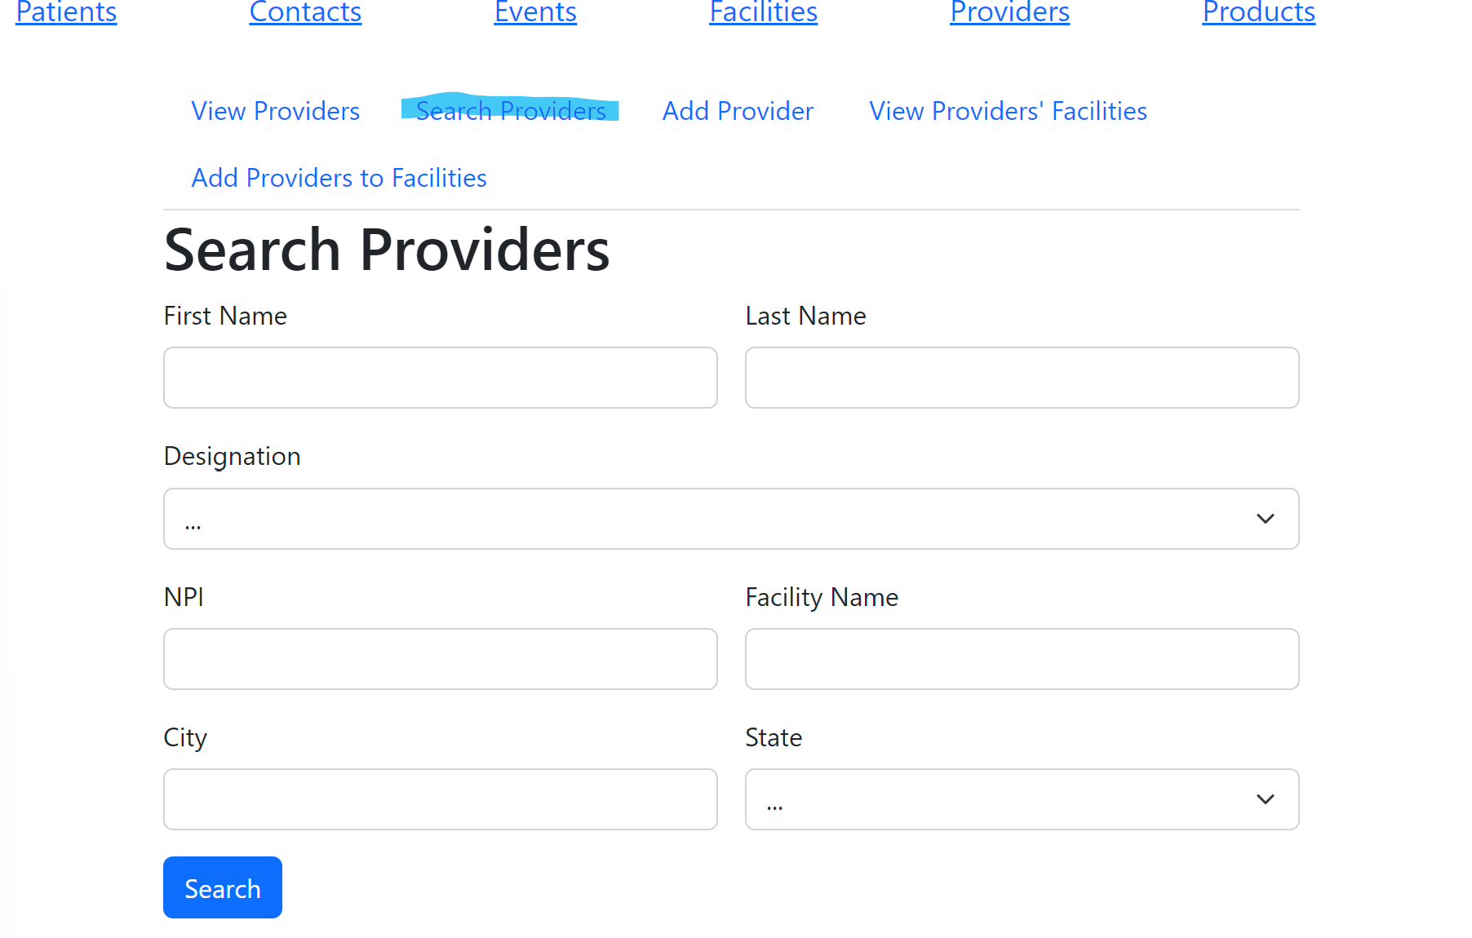
* What suggestions do you have for the team in any areas where they are blocked or having difficulty? Detailed helpful feedback will receive higher credit.
  + No major suggestions. Mostly just aesthetically/logically. The one major suggestion would be to implement a search function with the capability to search based on a portion of the information the user is looking for. The group might have already been planning on implementing this function this way.
  + One other nitpicky suggestion is in the add new provider to give make the user come up with a title of their provider type, or in the add new contact page, possibly making the contact types optional, as the user is able to opt in or out of those communication styles. Not a necessary implementation, but it would be cool to see ( I know this would take more time to implement)